**SparkSQL with Scala and Screenshot of the results obtained from the SparkSQL commands in Scala. :**

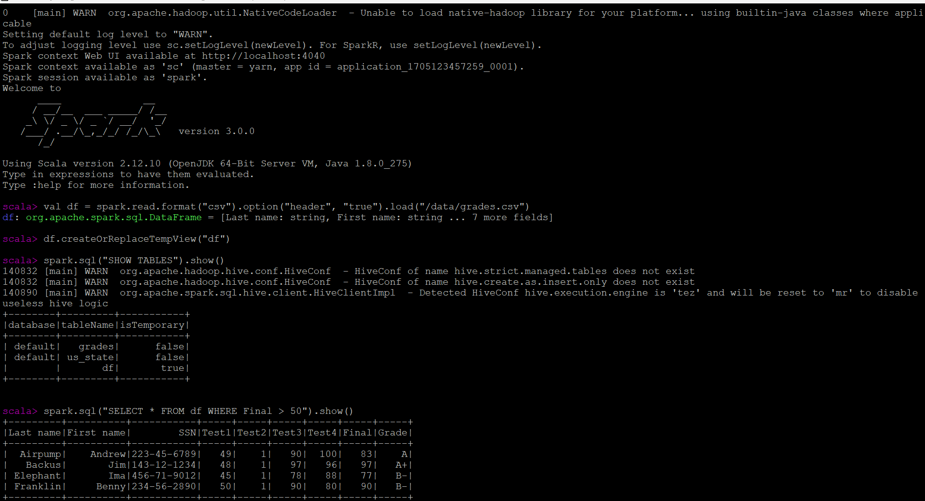

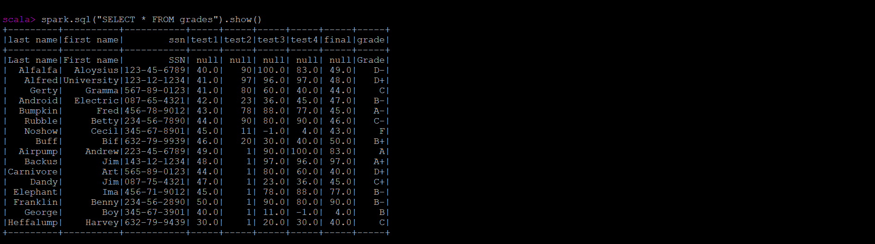

**Screenshot of your 3 other SQL query results:**

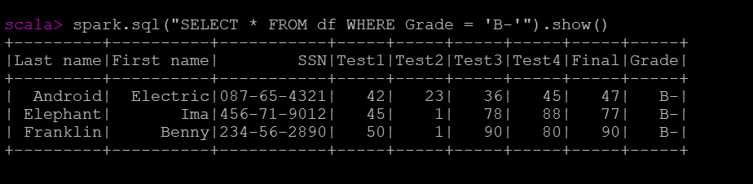

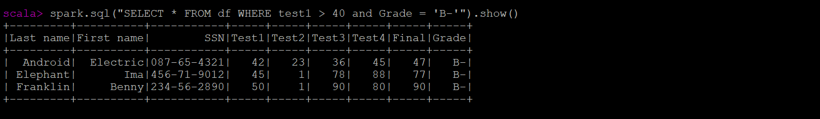

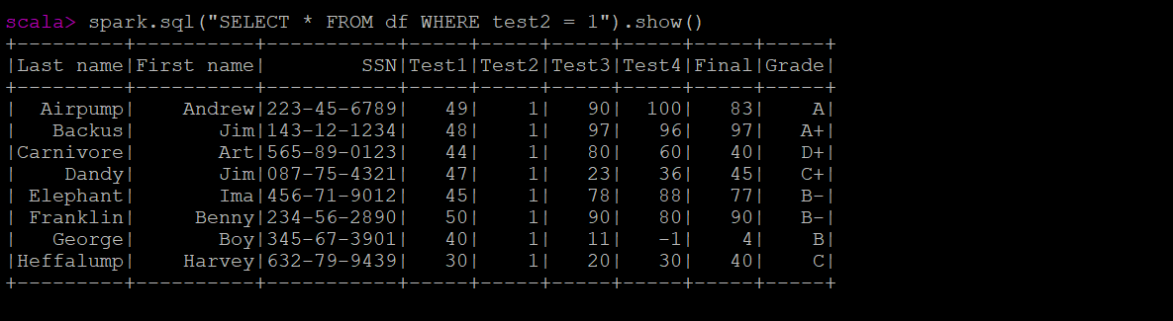

**Screenshot of the results obtained from the SparkSQL commands in Python :**

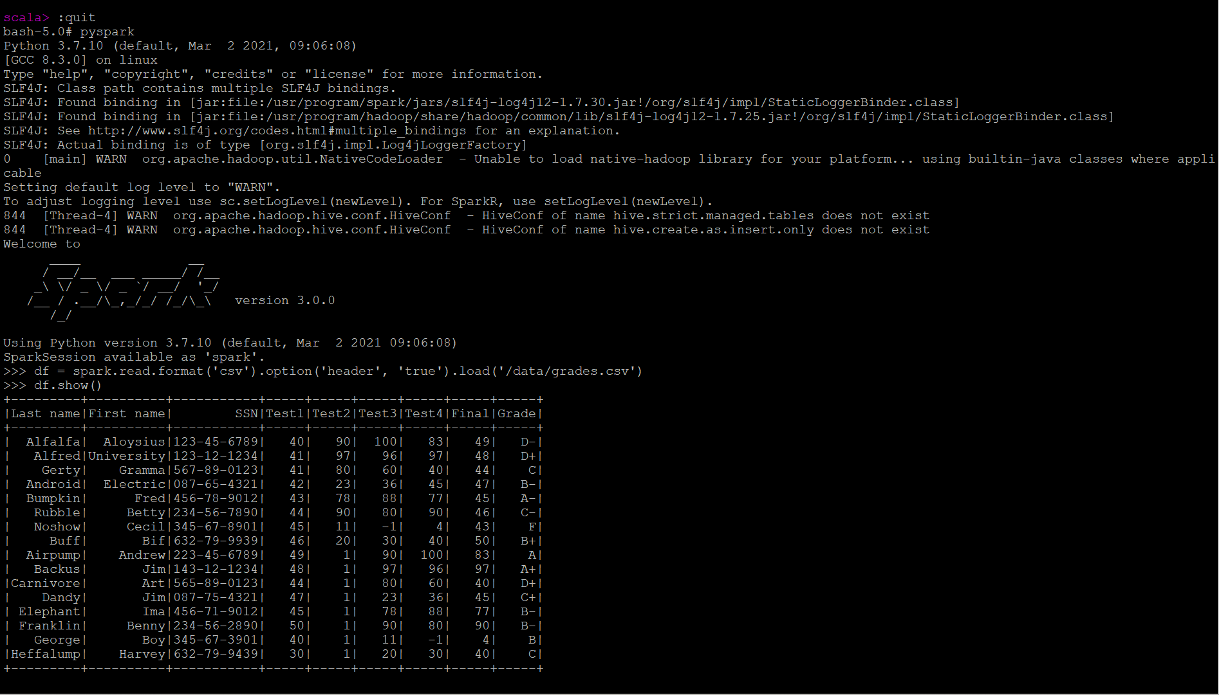

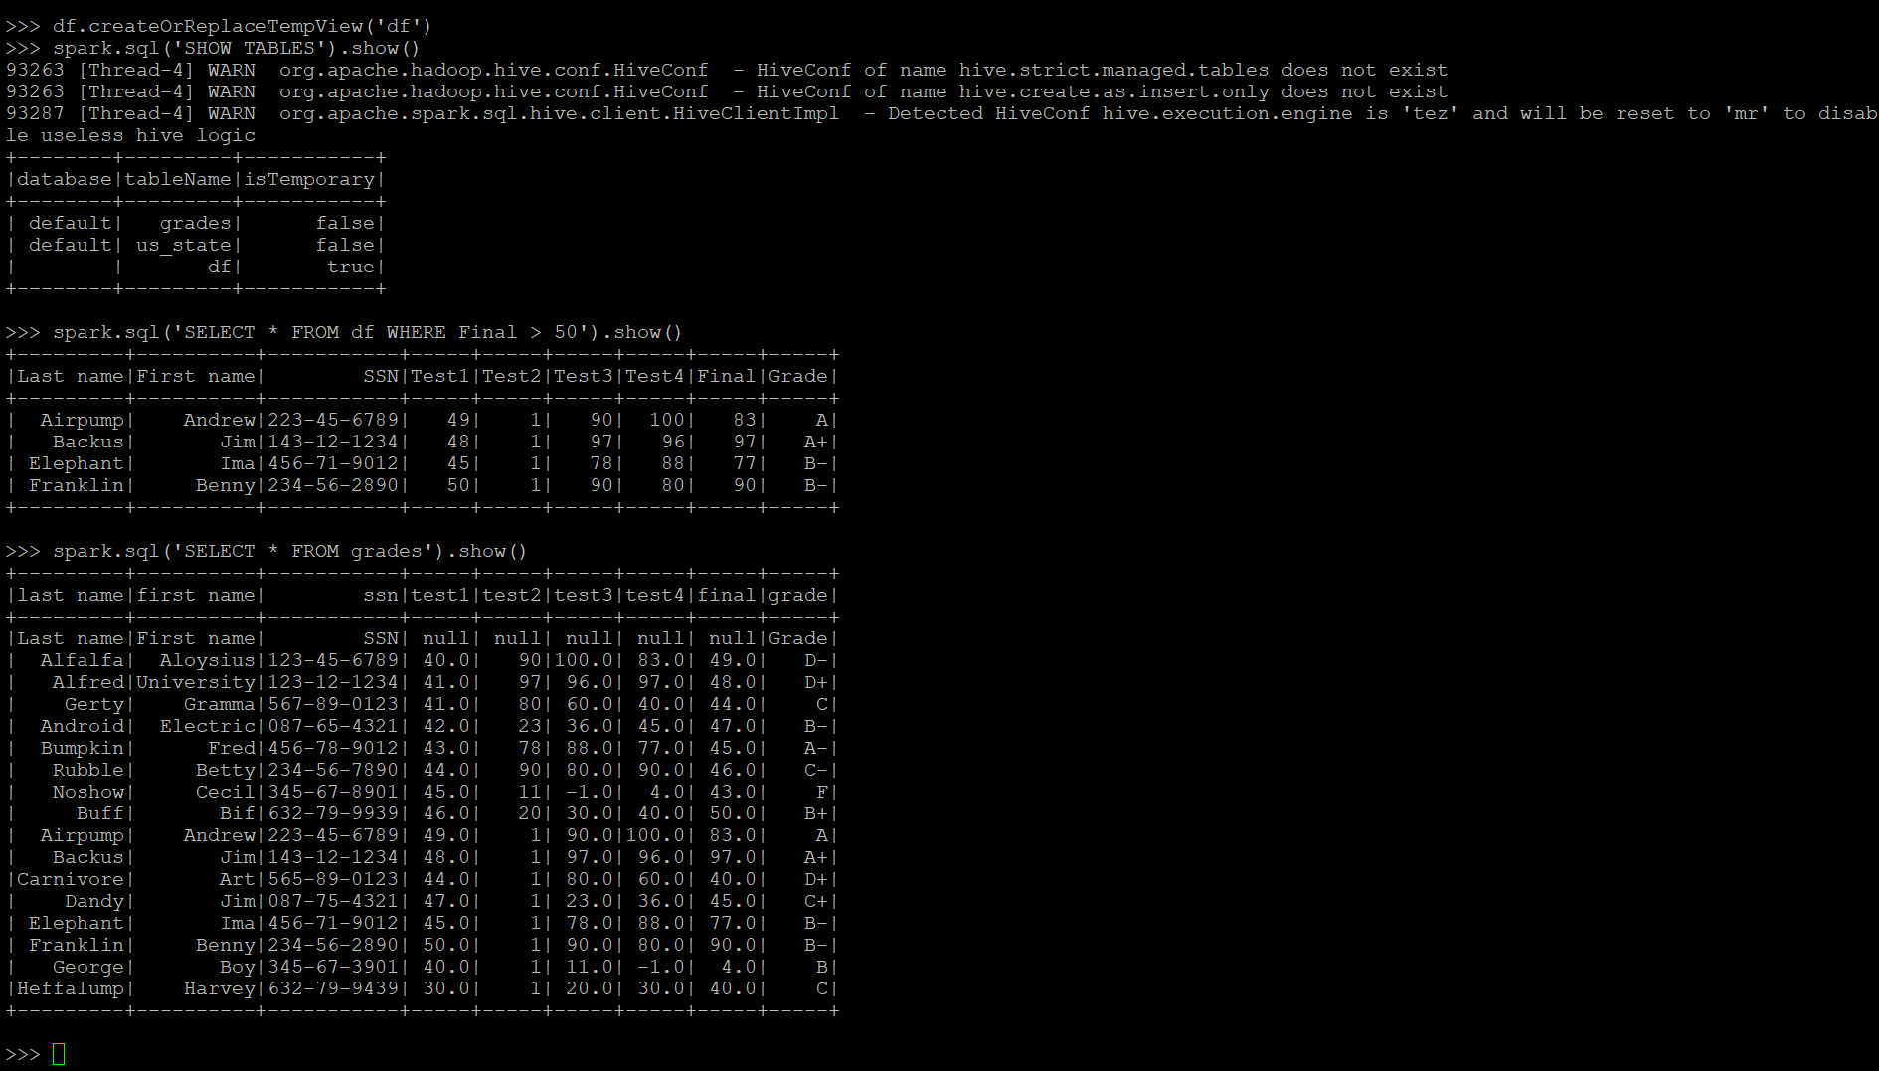

**Screenshot of your 3 other SQL query results:**

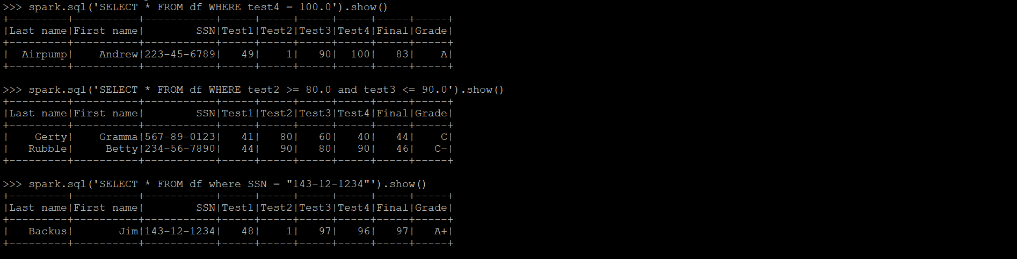

**SparkSQL with Custom Data Set from week-3 :**

val df1 = spark.read.format("text").option("header", "true").load("/data/us_state.txt")

df1.createOrReplaceTempView("df1")

spark.sql("SHOW TABLES").show()

spark.sql('SELECT * FROM us_state').show()

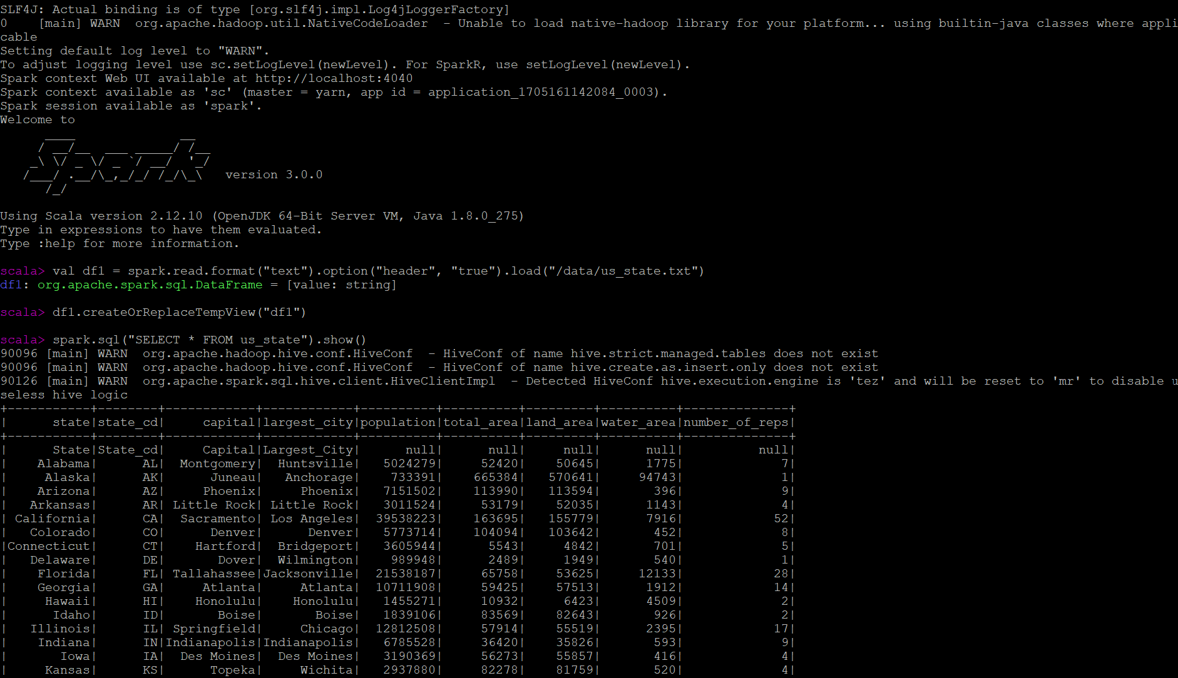

Screenshots of 1st select statement from us_state table to select all columns where state_cd = ‘NE’;



Screenshots of 2nd select statement from us_state table to select State, State_cd, Capital, Largest_City, Population, Number_of_Reps where Capital and Largest_City is same ;

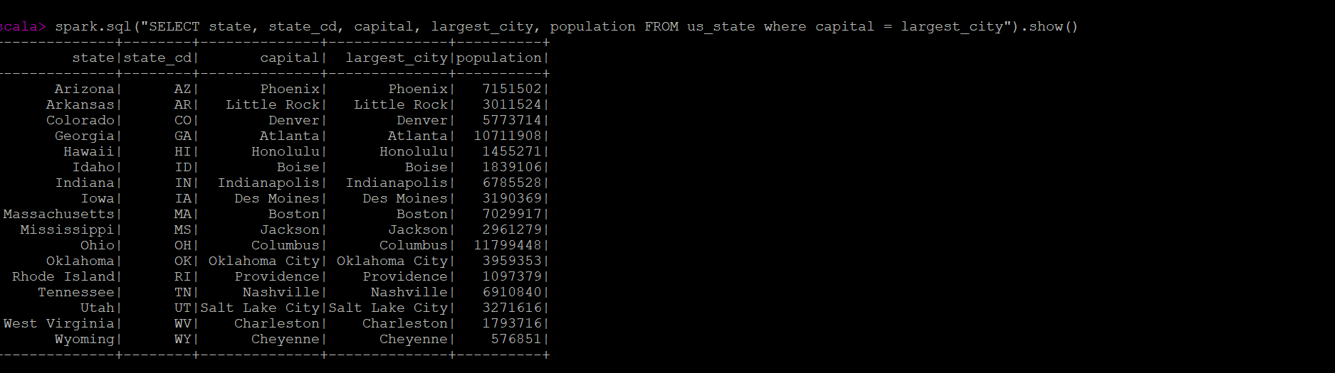

Screenshots of 3rd select statement from us_state table to select all columnswhere Number_of_Reps >= 10;

